 | MINISTRY OF EDUCATION AND TRAINING  FPT UNIVERSITY

Capstone Project Documents
Toll Fee Management
Unstopable
Group Members
  Nguyễn Anh Nhật Linh | 00499
  Nguyễn Duy Vũ | 00521
  Trần Hải Đăng | 00357
  Nguyễn Xuân Hiếu | 00380
  Tô Văn Quân | 00425
S
pervisor
Teacher Nguyễn Văn Sang
Ext Supervisor | Huỳnh Anh Dũng,Nguyễn Tất Trung
Capstone Project code | TFM

Hanoi, June 2011

Record of Changes
Date | Change Item | Description | By | Version
10/06/2011 | All | Create the document | LinhNan | 1.0

Table 1-1: References

TABLE OF CONTENTS
Part 1 INTRODUCTION
TABLE OF CONTENTS 3
1 Design overview 5
1.1 Overview 5
1.2 Definition and acronyms 5
2 Architecture design 6
2.1 Basic Structure 6
2.2 Architecture Design 6
2.2.1 PNRS Components Design 6
2.2.2 TCMW Components Design 7
2.2.3 DSS Components Design 7
3 Detailed design 8
3.1 PNRS design 8
3.1.1 Login/Switch User 8
3.1.2 Search 9
3.1.3 Auto plate number recogniton 10
3.1.4 Enter plate number info 10
3.1.5 Get update price list 10
3.1.6 View help 11
3.1.7 Print ticket 11
3.1.8 Enter transport type info 11
3.2 TCMW design 11
4 Database Design 12
4.1 Entity-Relationship Diagram 12
4.2 Table Design 12
4.2.1 Table Car 12
4.2.2 Table Car_Groups 13
4.2.3 Table car_type 13
4.2.4 Table evidence 14
4.2.5 Table fare 14
4.2.6 Table role_permissions 15
4.2.7 Table roles 15
4.2.8 Table Station 16
4.2.9 Table ticket_registration 16
4.2.10 Table users 16
4.2.11 Table user_detail 17
4.2.12 Table transaction 18
4.2.13 Table ticket_type 18

Design overview

Overview
This document will show the technical and UI design of the TFM system. It includes 2 parts: the application and the website. In each part we will describe the architectural design and the detailed design of common functions and business functions. It also includes the design of database model, and overall design of user interface.
The architectural design describes the overall architecture of the system, and the architecture of each main component and subsystem. It will describe the patterns being used, the role of each component and the role of the system in the working environment.
The detailed design describes static and dynamic structure for each component and function. It includes class diagrams, class explanations, and sequence diagrams of the main use cases. The detailed design uses notations of .NET framework 4.0 and C# 4.0 as they are the framework and language for developing the system.
The database design describes the relationship between entities, and details of each entity. It uses notations of SQL Server 2008 as it is the database server for developing the system.
The user interface design describes the layout of the system, and some design for the screens.

Definition and acronyms
Acronyms | Definition | Note
TFM | Toll Fee Management | Name of project
PNRS | Plate Number Recognition System | Name of main application that’s used to recognize plate number.
TCMW | Toll Collection Managerment Website | The website that’s used to manage toll collection.

Table 1-2: Definition and acronyms

Architecture design

Basic Structure
Basic structure of the system is described in the following figure:
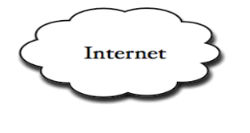
Database
Server
TCMW
DSS
Vietnam Register System database
Web service
Clients
Browser
PNRS app
Get data
Update data

Architecture Design

PNRS Components Design
The following diagram describes components of PNRS.

No | Name | Language | Description
1 | PNRSCtrl | C# | - Main controller of PNRS, controls main business of PNRS.  - Load and manage all GUI components to create main screen of PNRS.
2 | LoginCtrl | C# | - Entry point of PNRS, control loging in and switching user in PNRS of users.
3 | ImageProcessCtrl | TBD | - Main core of PNRS, provide features to process place number recognition: receive signal from sensor, shot image and recognize it.
4 | GetUpdatePriceListCtrl | C# | - This component process viewing and updating latest price list.
5 | HelpDisplayCtrl | C# | - Show usage guideline to user.
6 | VideoDisplayCtrl | C# | - Process getting image information from camera and displaying on screen.
7 | SearchCtrl | C# | - Control all search activities of user on PNRS, provide features for user to search and display result on screen.
8 | PlacaNumberInfoDispCtrl | C# | - Display place number info after recognizing activity.  - Provide features for users to manipulate when PNRS cannot recognize inputed image.
9 | DBAccessor | C#
10 | LogCtrl | C# | - Provide features to process logging file, logging event for tracing bugs if have.
11 | Utilities | C# | - Provide all common such as constants, common methods that all components of PNRS use

TCMW Components Design

DSS Components Design

Detailed design

PNRS design

Login/Switch User

Class Diagram
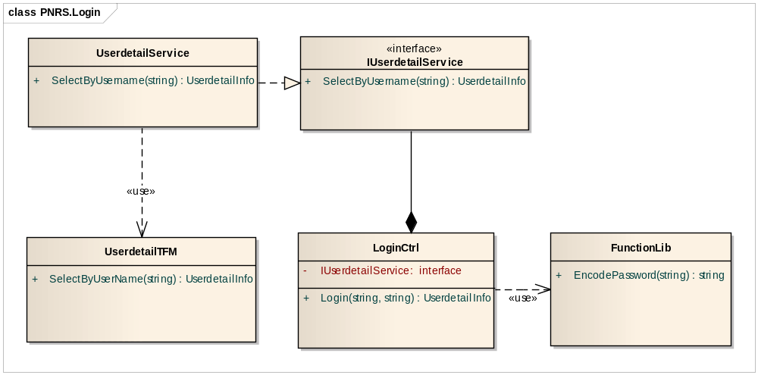

Class Explanations

IUserdetailService interface
- Attributes
N/A
- Operations

Sequence Diagram

Login
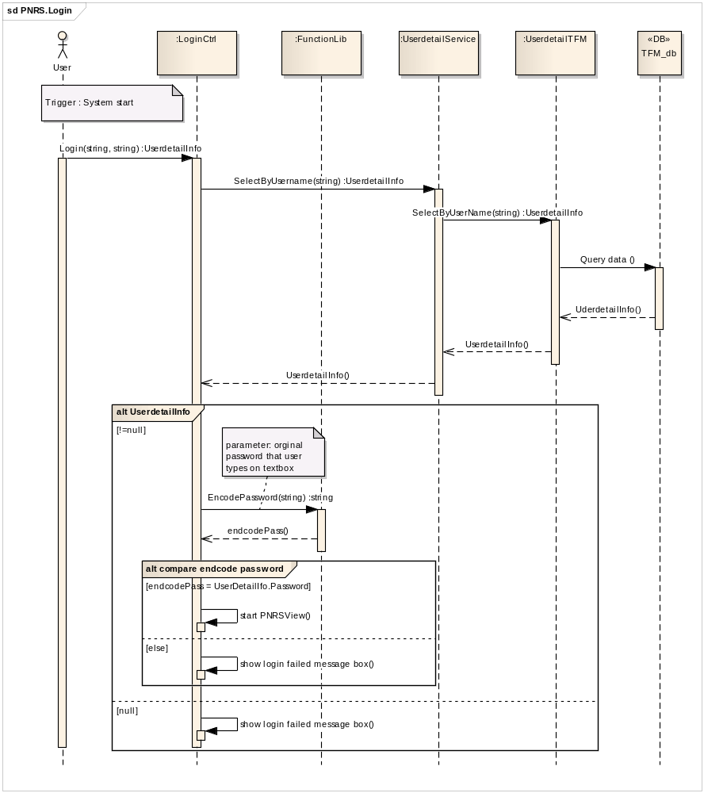

Switch user

Search

Class Diagram

Class Explanations

Sequence Diagram

Auto plate number recogniton

Class Diagram

Class Explanations

Sequence Diagram

Display camera

Shoot image

Recognize plate number

Auto print ticket

Enter plate number info

Class Diagram

Class Explanations

Sequence Diagram

View and get update price list

Class Diagram

Class Explanations

Sequence Diagram

Display price list

Get update price list

View help

Class Diagram

Class Explanations

Sequence Diagram

Print ticket

Class Diagram

Class Explanations

Sequence Diagram

Enter transport type info

Class Diagram

Class Explanations

Sequence Diagram

TCMW design

Database Design

Entity-Relationship Diagram
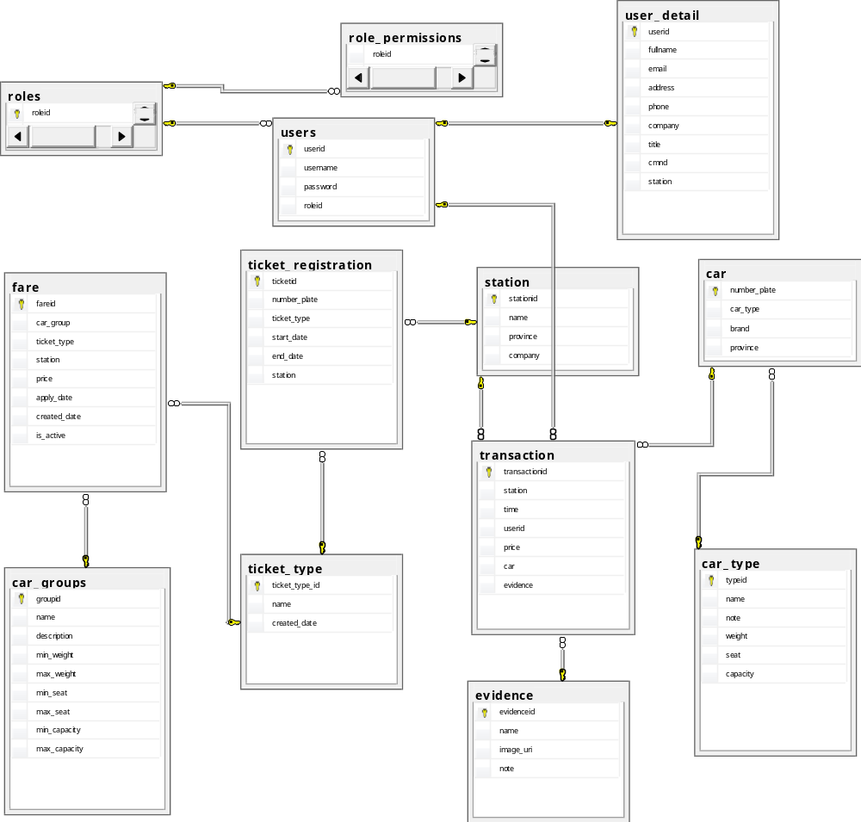

Table Design

Table Car
No | Field Name | Type | P/F Key | Allow Nulls | Description
1 | number_plate | Nvarchar | P | No | The number plate of the car and this is indentify primary key of this table.
2 | car_type | int | P | No | The primary key reference to table car_type which identify car type. [car].cartype = [cartype].typeid
3 | brand | nvarchar(200) |  | Yes | Brand of the car. Ex Toyota, Honda, ... etc..
4 | province | nvarchar(50) |  | Yes | Province where the car register

Table Car_Groups
No | Field Name | Type | P/F Key | Allow Nulls | Description
1 | groupid | int | P | No | Indentify primary key of the Car Group
2 | name | nvarchar(50) |  | No | Name of the car group.
3 | description | nvarchar(500) |  | Yes | Description of the car group
4 | min_weight | nvarchar(200) |  | Yes | Min of weight of the car in this group
5 | max_weight | nvarchar(200) |  | Yes | Maximum of weight of the car in this car group
6 | min_seat | nvarchar(200) |  | Yes | Minimum value amount of seats of the car in this car group
7 | max_seat | nvarchar(200) |  | Yes | Maximum value amount of seats of the car in this car group
8 | min_capacity | nvarchar(200) |  | Yes | Minimum capacity’s value of the car in this car group
9 | max_capacity | nvarchar(200) | F | Yes | Maximum capacity’s value of the car in this car group

Table car_type
No | Field Name | Type | P/F Key | Allow Nulls | Description
1 | typeid | int | P | No | Indentify primary key of the Car Group
2 | name | nvarchar(200) |  | Yes | Name of the car type
3 | note | nvarchar(500) |  | Yes | Note or description of the car type, what is the station administrator want to note about the car type.
4 | weight | nvarchar(200) |  | Yes | The weight of car in this type
5 | seat | nvarchar(200) |  | Yes | The seat amount of car in this type
6 | capacity | nvarchar(200) |  | Yes | The capacity of car in this type

Table evidence
No | Field Name | Type | P/F Key | Allow Nulls | Description
1 | evidenceid | int | P | No | Indentify primary key of the evidence
2 | name | nvarchar(50) |  | Yes | Name of the evidence
3 | image_uri | nvarchar(50) |  | No | The uri of evidence’s images which capture on the time stransport is at station.
4 | note | nvarchar(4000) |  | Yes | Note of the evidence.

Table fare
No | Field Name | Type | P/F Key | Allow Nulls | Description
1 | fareid | int | P | No | Indentify primary key of this fare.
2 | car_group | int |  | No | The car_group key, reference to table car_group
3 | ticket_type | int |  | No | The ticket tpe key, reference to table ticket_type ( [fare].ticket_type = [ticket_type].ticket_type_id )
4 | station | int |  | No | The station key, This is the station where apply this fare. Reference to table station  [Fare].station = [station].stationid
5 | Price | nvarchar(200) |  | No | Price value of this fare.
6 | Apply_date | int |  | No | The Date when the station apply this fare
7 | Created_date | int |  | Yes | The date when the station created this fare
8 | Is_active | int |  | No | This value indentify the fare is available or not at current time.

Table role_permissions
No | Field Name | Type | P/F Key | Allow Nulls | Description
1 | Roleid | int | F | No | The foreign key reference to table Role  [Role_permissons].roleid = [roles].id
2 | permission | nvarchar(50) | F | No | The permission name which are constants in system to define permission for users.

Table roles
No | Field Name | Type | P/F Key | Allow Nulls | Description
1 | Roleid | int | P | No | The indentify primary key of Role.
2 | name | nvarchar(50) | F | No | The role name

Table Station
No | Field Name | Type | P/F Key | Allow Nulls | Description
1 | stationid | int | P | No | The indentify primary key of station
2 | name | nvarchar(50) | F | No | Name of this station
3 | Province | Nvarchar(200) |  | Yes | Province where this station is
4 | Company | Nvarchar(200) |  | Yes | The company manage this station

Table ticket_registration
No | Field Name | Type | P/F Key | Allow Nulls | Description
1 | Ticketed | int | P | No | The indentify primary key of station
2 | Number_plate | nvarchar(50) | F | No | The foreign key reference to table car. Define which car register ticket
3 | Ticket_type | int | F | Yes | The foreign key reference to table ticket_type. Define ticket type and price
4 | Start_date | int |  | Yes | The date this ticket begin available
 | End_Date | int |  |  | the date this ticket not available
 | Station | int | F | No | The station where car register this ticket.

Table users
No | Field Name | Type | P/F Key | Allow Nulls | Description
1 | userid | int | P | No | Indentify primary key of user.
2 | username | nvarchar(50) |  | No | The name which user use to login
3 | password | nvarchar(50) |  | No | The password which user use to login
4 | roleid | int |  | No | This is id of permission of user. Reference to table  [users].roleid = [role_permission].roleid

Table user_detail
No | Field Name | Type | P/F Key | Allow Nulls | Description
1 | userid | int | P | No | Indentify primary key of user.
2 | fullname | nvarchar(50) |  | No | First name and last name of user
3 | email | nvarchar(50) |  | No | Email of user
4 | address | nvarchar(50) |  | Yes | Address of user
5 | phone | nvarchar(50) |  | Yes | Phone of user
6 | company | nvarchar(50) |  | Yes | Company of user
7 | title | nvarchar(50) |  | Yes | Function of user
8 | cmnd | nvarchar(50) |  | Yes | CMND of user
9 | station | nvarchar(50) |  | No | Station where user work for

Table transaction
No | Field Name | Type | P/F Key | Allow Nulls | Description
1 | transactionId | int | P | No | Indentify primary key of transaction.
2 | station | int |  | No | The station where the transaction happen
3 | time | int |  | No | Time when transaction happen
4 | userid | int |  | Yes | Id of user who create transaction
5 | price | Int |  | No | Fee which driver pay
6 | car | nvarchar(50) |  | Yes | Number of plate
7 | evidence | int |  | Yes | id of image which camera capture the car

Table ticket_type
No | Field Name | Type | P/F Key | Allow Nulls | Description
1 | ticket_type_id | int | P | No | Indentify primary key of ticket_type
2 | Name | nvarchar(200) |  | No | Type of ticket
3 | created_date | int |  | No | The date when the ticket create

Appendix 1: ….

